
Package Request Form-Xenapp
Version 5.9
HCL – Application Packaging Factory

Contents
1. Introduction 3
2. Application Information* 3
3. Application Dependencies and Resource Requirement* 3
4. Package Information / Customization details 4
5. License Information 4
6. Installation and Configuration Steps* 5
7. User Defined Test * 5

Introduction

In order to correctly package an application, a certain amount of information is required. This form details the information requirements and needs to be filled in before packaging of an application can commence. Basic instructions are provided below.

Please note: Sections marked with asterisk (*) symbol are mandatory.

Application Information

Application Name* | Firefox ESR
Application Version* | 91.6.0
Application Manufacturer* | Mozilla
Product Area\Responsible Team *  Provide the name of the Product Area\Team or Application Responsible Team name in this Field. You can also provide the ServiceNOW queue name as well. | HCL WAMS
Type of Request*  New – new request for this platform  Upgrade – upgrade of a previous app  Coexist – coexisting with a previous version  Specify the previous application for Upgrade and Coexist alternatives  Please Note: For AppV packages the upgrade is not handled | Upgrade  All previous versions should be uninstalled from the machine and upgraded with this latest version i.e. 91.6.0
Application Distribution AD group*  Provide the existing Active Directory group if the application exist, you can check the existing groups from http://helpdesk2.hm.com/portal/  For new application you can keep this field blank. | For Workplace (Prod): SP01 SBCXA Firefox CU HUB2 V  For Workplace (Test): DEVSP01 SBCXA Firefox CU HUB1 V  For Workplace (Prod): SP01 SBCXA Firefox CU HUB1 V  For Workplace (Test): DEVSP01 SBCXA Firefox CU HUB1 V  For Workplace (Prod): SP01 SBCXA FireFox CU HUB3 V  For Workplace (Test): DEVSP01 SBCXA Firefox CU HUB1 V
Application Persistence*  Please select the relevant option if it will remain as permanent or temporary in the environment.  Please select either of these check box | If you select Temporary select the duration  Choose an item.

Application Dependencies and Resource Requirement

Please specify the software and hardware requirements of the application. Please include any applications that the application is dependent upon and/or integrates with.

Software*
Dependencies and Integrations  List known Integrations or Dependencies with or to other Applications eg, MS Office, Adobe | Integrated with HM Firefox Config 4.41
Pre-requisites  Specify Pre Requisites (components) that are required in order for the application to install & run (i.e. ODBC, .NET framework, JRE Runtime etc.) | HM Firefox Config 4.41 must be installed on the machine, this should not be a dependency that installs automatically but just set as a requirement for the deployment to run.
Restart Option*

Please select either of these check box
Note: If Restart Option is Yes please mention the reaon.
Compatibility *
For new applications, these two parameters are mandatory. Without confirming these two options application will not be deployed in Citrix.
Is the application compatible with Windows Server 2016? *
Please select either of these check box

Is this application certified by vendor to run in a multi-user environment? (Multiple users running the application on same VM\server)?*
Please select either of these check box

Resource requirement
CPU, Memory, Disk, Network*
Mention any specific resource requirement for packaging & publishing in production.
Specify total number of concurrent users and select the relevant option*

Select the relevant check box based on the new and existing users.

Package Information / Customization details

Application Type* | Select the relevant option if it is a Client/server based application
Web URL (Browser Based Application)*  (Microsoft Edge Chromium is the primary browser, if application is selected for other browser mention the reason)  Note: As there is no premium support for Firefox and Chrome so any issues with these browsers can be supported in best effort basis. Also note no request will be taken for Internet Explorer as well. | We have the application in the environment which is deployed on Firefox as of now so we need to deploy the application in the production.
Package Request Type
Package type will be decided on the basis of Application Compatibility Testing report generated by HCL. Please make selection in case you have specific requirements.
Are there any specific launch method for the application? | Specify Why? ________________________________
Location of Application Users* | Note: If you are unsure please Select 3 groups all together.
Language*  What language setting should be used in the application | ________________________________
Customization Details
E.g. any customization is needed in the package, like adding any proxy settings, home page etc.
Application Severity * | Note:Super Express Request is only for BOPO request.
Reason for Express*
(Mention the business reason for creating the Expresss request)

License Information

Please specify the Application license information:

Licensed to | H&M AB
License is required
License Type *
Specify if the license is per device or per user
License source
Enter license key or source to license file or server

Installation and Configuration Steps*

Please detail full installation steps, including all options selected and the configuration required. This will dictate how the installation is performed, setup and finally runs.
Note: Please provide the installation and configuration steps from the raw media (vendor installer).Preferable doc and pdf documents.

 | Screenshot | Input
MSI Windows
Run the following command where the <full path to folder> variable has been substituted for the full path to the folder containing the source files
<current version of firefox setup.exe> /INI="<full path to folder>\setup.ini"
Setup has completed when the .exe file is not longer present as a process in the Task Manager
 |  | Copy the files from the Mozilla Firefox ESR folder in the .zip to the main installation directory
 |  | Create a shortcut to the Firefox executable from the Mozilla Firefox package, name it “Mozilla Firefox ESR v(version number)” (ex. Mozilla Firefox ESR v78.11,0
When putting the package into test or production the following dependency applications need to be updated in Citrix (in respective environment) to start with the new version:
SEC (Shareforce)
OFU
Enovia (Castor, QA)
Accenture GOE HYBRIS
Accenture HMC
Service NOW
MDM Admin
ADPVantage (Available in Store)
Chat Tools
SOTI
Tamigo
Principle Supplier
Store Tablet Accounts
SEC office 365
Sim
Delcon
Vergic ChatTools
Nunace
Synapps
SOTI CLOUD
Account Portal
SIM CH COS
Eflow
Office365
PeopleConnet
GMAO Firefox
Product Plan
Share Force Japanese
TaxCom portal
1C – Docflow
1C – Salary System

User Defined Test *

Please provide validiation steps so that packaging team can ensure that package is created as per the requirement.
Please provided supported screenshots.

 | Screenshot | Input

Timeline for Application Packaging Service
Depending on urgency, two different options for Application Packaging can be chosen. Both options are described below.

Normal Packaging
Timeline for packaging when using Normal service:
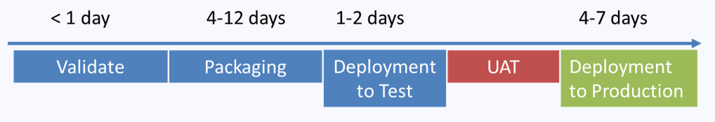
Packaging time varies as follows depending on the complexity of the package.
Simple: packed within 4 Days
Medium: packed within 8 Days
Complex: packed within 12 Days
Express Packaging​
Timeline for packaging when using Express service: 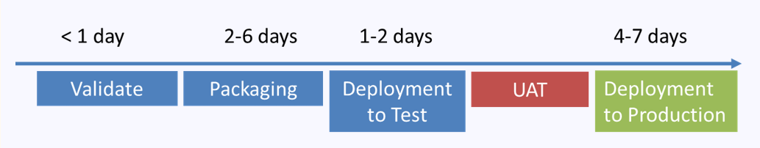
Packaging time varies as follows depending on the complexity of the package.
Simple: packed within 2 Days
Medium: packed within 4 Days
Complex: packed within 6 Days

Super Express Packaging
Timeline for packaging when using Super Express Service (BOPO only):

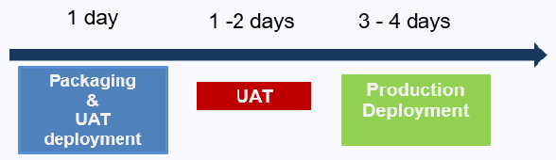
Simple: packed within 1 Day

Note: This is only for BOPO packages only, also package which will be categorized as SIMPLE in BOPO will be considered in Super Express.
Glossary

Contact Details

Owner The business contact who is responsible for the evolution of the application within the business

Technical Support Rep Could be the application developer, someone who is familiar with how the application is set up, i.e. installs details, database connectivity. Someone who knows what to do if the application is not working

Requirements & Dependencies

Software Any applications or files and their locations required for the application to run
Hardware This includes but is not limited to access to dongles, scanners, printers, memory, hard disk space, etc.
Infrastructural These can be some network dependency, this is the middleware required to
run the application, i.e. network
Or back-end databases, ODBC information, etc.

License Information The serial numbers required to setup or run the application, if it is a single user or a site license, dongles, licenses servers, etc.

Installation and
Configuration Steps A set of step by step instructions to follow during the application setup routine.

